1. Accept the user's first and last name and print them in reverse order with a space between them

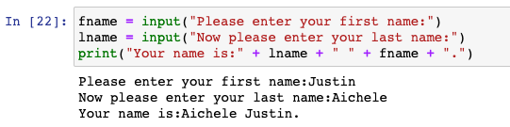

1. Accept an integer (n) and compute the value of n+nn+nnn

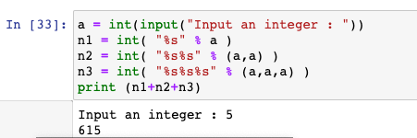

1. Ask the user "What country are you from?" then print the following statement: "I have heard that [input] is a beautiful country!"

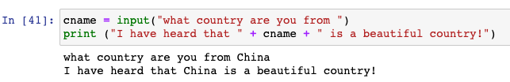

1. What is the output of the following Python code

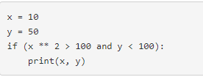

Output → **None**

1. What is the output of the following addition (+) operator

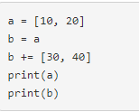

Output → **[10, 20, 30, 40]**

**[10, 20, 30, 40]**

1. What is the output of print(2%6)

Answer → **2**

1. What is the output of print(2 * 3 ** 3 * 4)

Answer → **216**

1. What is a text editor?

Answer → **A type of computer program that allows you to edit plain text. (i.e. Notepad or TextEdit)**

1. What is python?

Answer → **Python is an object-oriented computer programming language.**

1. What is a jupyter notebook and list two alternatives.

Answer → **Jupyter Notebook is an open-source web app that allows you to create and share documents that contain live code. Two alternatives to this would be RStudio or PyCharm.**